7810 S. Dixie Highway
West Palm Beach, FL 33405
800-588-9296
www.CubicleCurtainFactory.com

Versitrack
Track Specifications

Track:
Aluminum extrusion (3/4” X 3/4"), powder coated white, baked on, tough, smooth surface, no paint chipping and pre-lubricated with a Teflon coat. 12” radius corner bends are standard. No lubrication needed and no dust build up; a dry lubricant to minimize carrier drag.

Carriers:
All Versitrack carriers are made of Delrin, an UV resistant heavy-duty plastic. All carriers come with stainless steel hooks for maximum durability.

Brackets:
Brackets are made of steel and have the same white powder coated finish as the track.

Installation:
The ceiling brackets are set every 48” with a high load (12 lbs. per foot). Fasten the ceiling brackets into place and then the track is simply “clicked” into place. The holding screw is then tightened into place to securely hold the track to the ceiling.
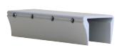
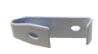
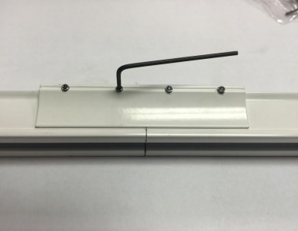
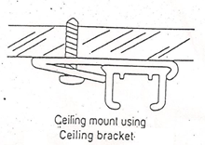
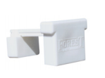
Ceiling Clip Connector
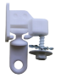

KS End Gate CS End Gate Ball Bearing Carrier

